Exhibit 6.1: UX Check Results

# Heuristic: Match between system and the real world

## Severity: 3

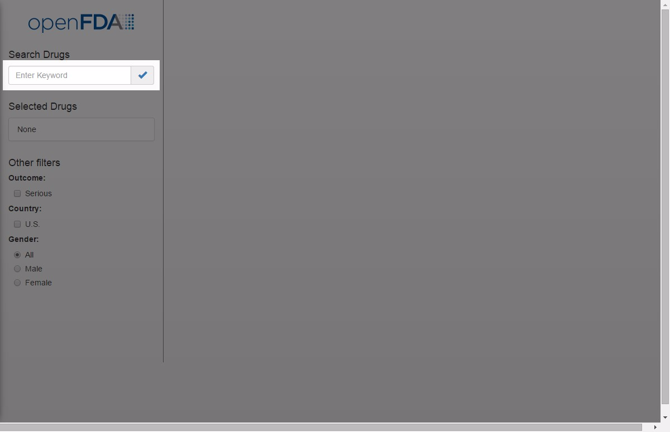

## Notes:

Enter keyword is vague, especially if the user can only search by drug names.

## Recommendation:

Use "Enter Drug Name" or an example like "e.g. Aspirin"

# Heuristic: Flexibility and efficiency of use

## Severity: 2



## Notes:

1. Checkmark not really common for this type of button. 2. User has to click this button to display results, instead of just entering after they typed.

# Recommendation:

1. Replace the icon with "Go". 2. Allow user to press Enter key to display results.

# Heuristic: Consistency and standards

## Severity: 0

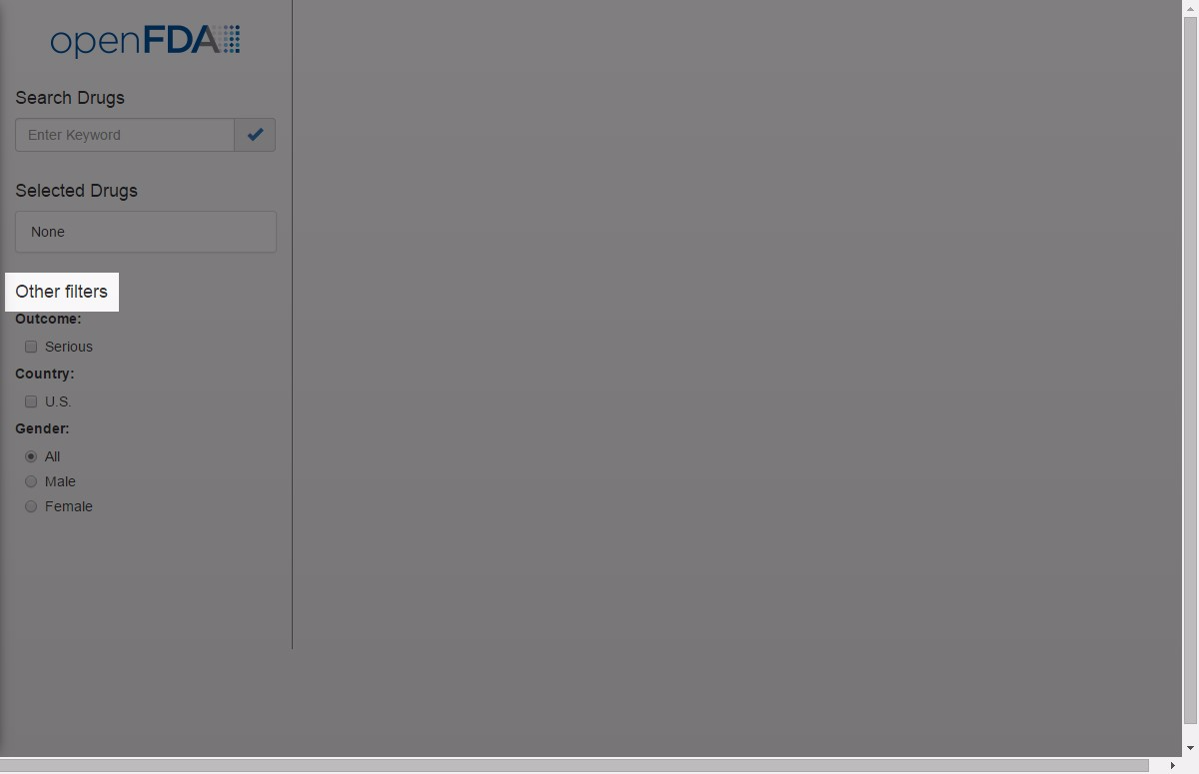

## Notes:

The word "Other" makes me wonder if there are other filters on the page that I don't see yet.

## Recommendation:

Just "Apply Filters" should be clear enough.

# Heuristic: Help and documentation

## Severity: 1

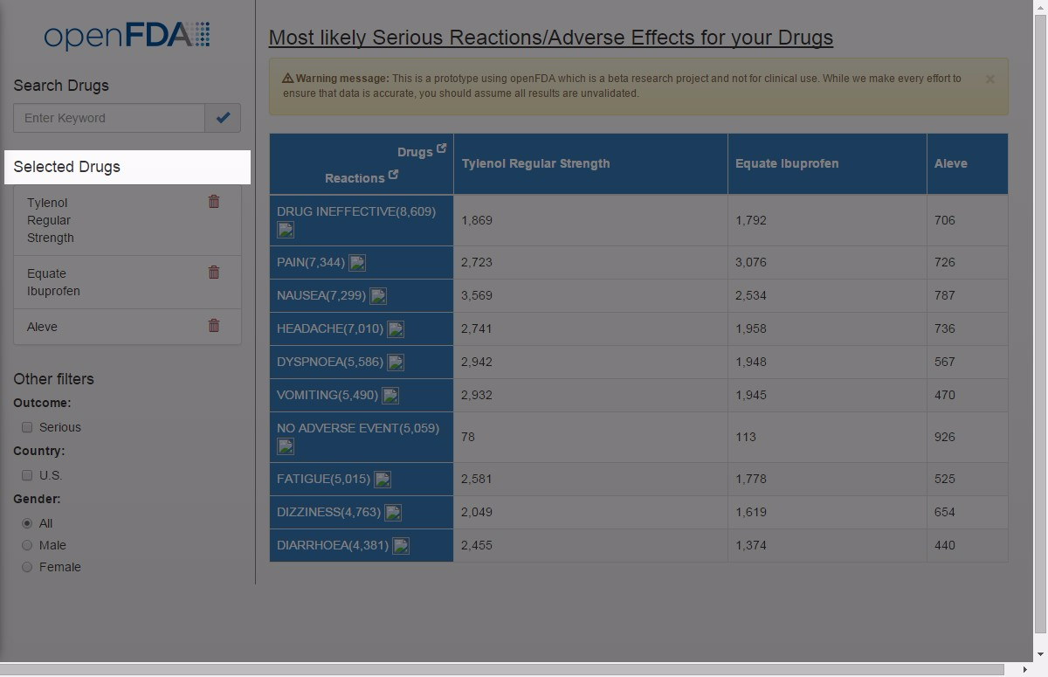

## Notes:

No guidance as to how many drugs users can search by.&nbsp;

## Recommendation:

Display help text about the limit # of drugs that users can add.&nbsp;

# Heuristic: Aesthetic and minimalist design / Space

## Severity: 2

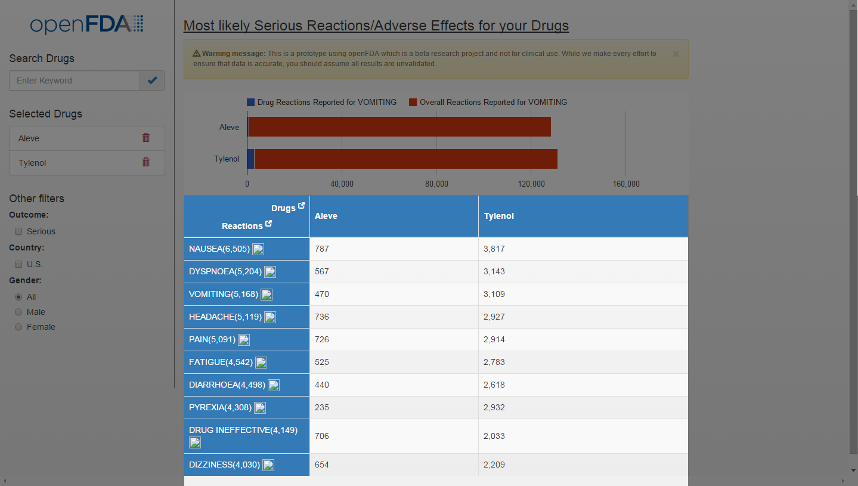

## Notes:

1. Data columns are unnecessarily wide - can confirm to size of text / data within the column. 2. Column headers are the same color - not visually distinguishing.

## Recommendation:

1. Allow the column width to dynamically adjust based on size of content. 2. Use different colors for the 1st row and 1st column to distinguish between reactions vs. drugs.

# Heuristic: Help and documentation

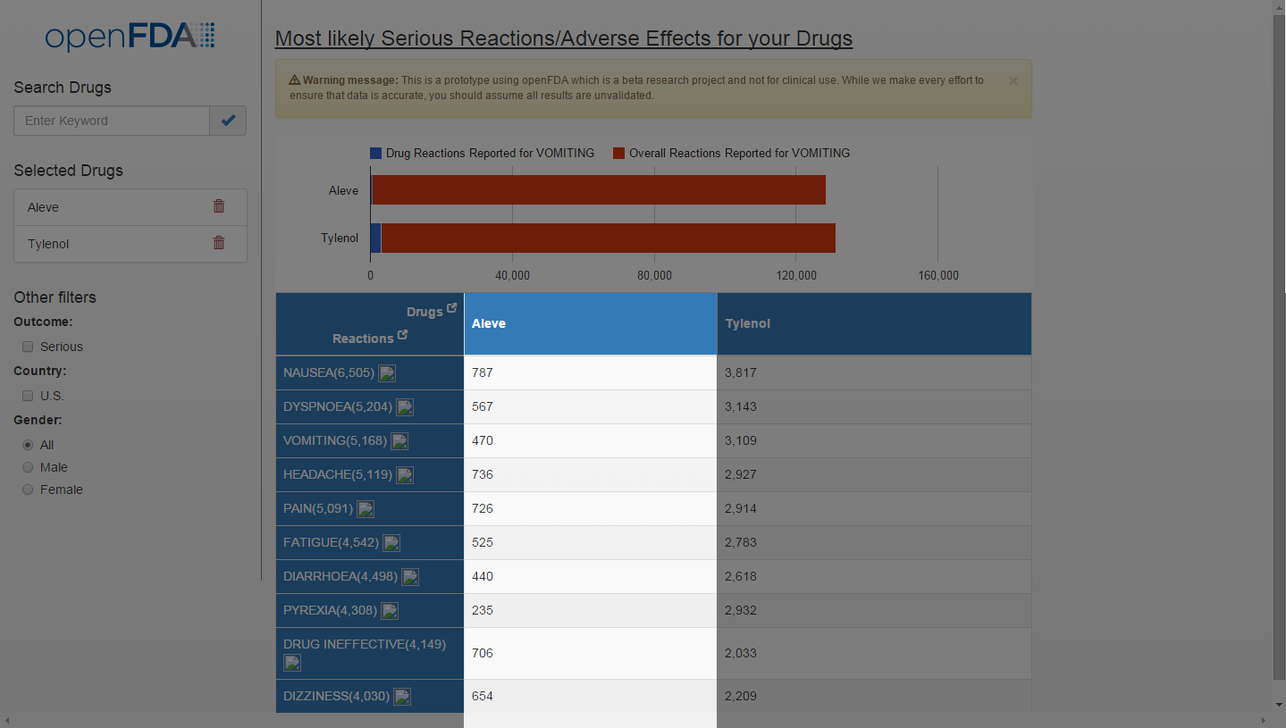

## Severity: 1

## Notes:

It’s not clear what the number represents – cases? People?

## Recommendations:

In this case, we should note somewhere that the numbers represent reported cases.

# Heuristic: Recognition rather than recall

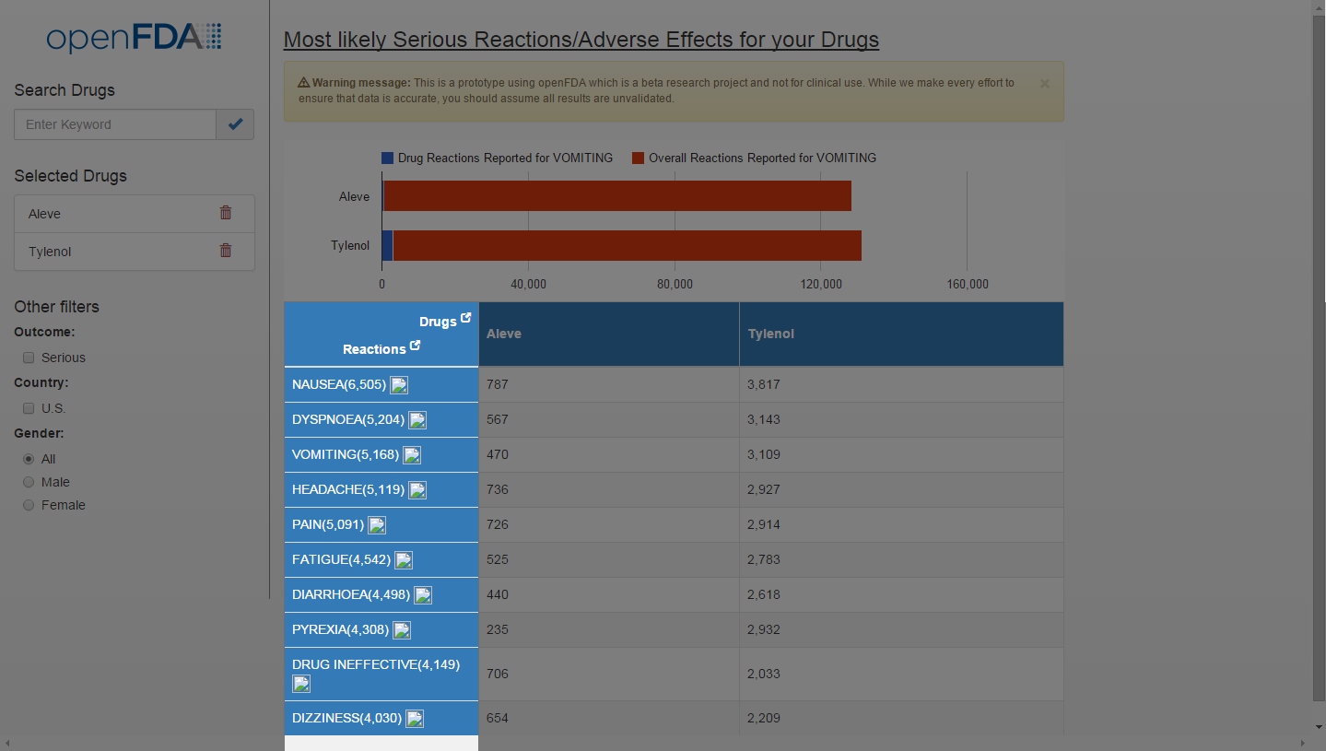

## Severity: 1

## Notes:

Although these are hyperlinks to Medline, it’s not clear that they are so until the user hovers over the word. Likewise with drug names.

## Recommendations:

Use the conventional standing for hyperlinks (underlining) to let the users know that they can click on them.

UX Check Results

# Heuristic: Visibility of system status

## Severity: 2

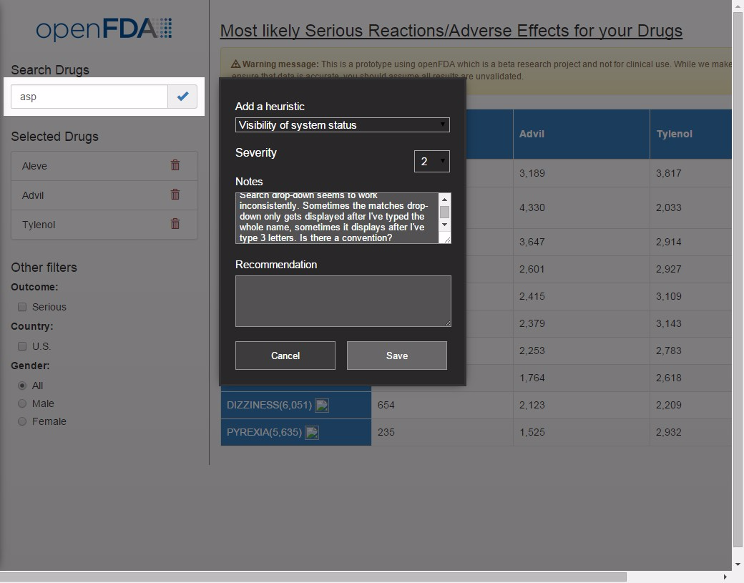

## Notes:

Search drop-down seems to work inconsistently. Sometimes the matches drop-down only gets displayed after I've typed the whole name, sometimes it displays after I've type 3 letters. Is there a convention?